**GIT: Wonders of Spain**

Madrid · Córdoba · Sevilla · Granada · Valencia · Barcelona

|  |  |  |  |
| --- | --- | --- | --- |
| http://www.sportandeu.com/wp-content/uploads/2015/11/gran-via_1072541.jpg | https://c2.staticflickr.com/4/3428/3273325719_4f19d09f5a.jpg | http://www.showmesevilla.com/images/plaza-espana.jpeg | http://fusterapartments.com/blog/wp-content/uploads/2015/06/la-sagrada-familia-wallpaper.jpg |

**day 1 Madrid**

English speaking assistance upon arrival at **Madrid airport**. **transfer** to the hotel in the city.

leisure time, enjoy your time in the capital. watching a football match in Santiago Bernabeu stadium might be a good idea.

overnight at hotel in Madrid.

**day 2 Madrid**

breakfast at the hotel.

half day **Madrid** **sightseeing.**

*this half-day visit offers a complete tour of the history and architecture of the city of Madrid:* ***Puerta de Alcalá, Cibeles, Puerta del Sol, Plaza de la Villa, Plaza Mayor****, Carrera de San Jerónimo, Calle Atocha, Reina Sofia Museum, Atocha main railway station, Ministry of Agriculture,* ***Prado Museum****, Banco de España, Paseo de* ***la Castellana, Bernabeu football stadium****.*

overnight at hotel in Madrid.

**day 3 Madrid - Córdoba**

breakfast at the hotel and check out.

**transfer** to **Córdoba.**

half day **Córdoba sightseeing,** *visiting the famous mosque/cathedral and the Jewish quarter*.

overnight at hotel in Córdoba.

**day 4 Córdoba - Sevilla**

breakfast at the hotel and check out.

**transfer** to **Sevilla**.

half day **Sevilla** **sightseeing.**

*the tour starts at the Isla de la Cartuja which was chosen as the site for the expo’92. the* ***Plaza de España*** *and the adjoining* ***Maria Luisa Park*** *are among the most pleasant and impressive public spaces in spain.*

overnight at hotel in Sevilla.

**day 5 Sevilla - Granada**

breakfast at the hotel and check out.

**transfer** to **Granada**.

half day **Granada** **sightseeing.**

*tour including the impressive* ***Alhambra*** *with its beautiful Nazari palaces and the Generalife.*

overnight at hotel in Granada.

**day 6 Granada - Valencia**

breakfast at the hotel and check out.

**transfer** to **Valencia .**

half day visit to **Oceanographic** of Valencia within **City of Arts & Sciences**.

*the Oceanographic of the city of arts and sciences is the largest aquarium in Europe and contains representatives of the world’s main marine ecosystems.* overnight in hotel in Valencia.

**day 7 Valencia - Barcelona**

breakfast at the hotel and check out.

**transfer** to **Barcelona**.

half day **Barcelona** **sightseeing.**

*enjoy Barcelona, discovering the most interesting places from the artistic and cultural point of view:* ***the Gothic Cathedral****,* ***Plaça Catalunya,******Passeig de Gràcia****,* ***Sagrada Familia****…*

overnight at hotel in Barcelona.

**day 8 Barcelona**

breakfast at the hotel.

leisure time in **Barcelona**, enjoy the weather and cuisine in Barcelona. shopping could be your first option in Barcelona or watch a football game.

overnight at hotel in Barcelona.

**day 9 Barcelona**

breakfast at the hotel and check out.

**departure transfer** to Barcelona airport.

**end of services**

**prices**

|  |  |  |  |  |  |  |
| --- | --- | --- | --- | --- | --- | --- |
| **package price per person** | **Nov - Mar** | | **Apr - Oct** | | **Jul - Aug** | |
| **standard class *hotels in Madrid, Sevilla, Valencia and Barcelona located in outskirts** | **pax** | **€** | **pax** | **€** | **pax** | **€** |
| **15-19** | 730 | **15-19** | 806 | **15-19** | 751 |
| **20-24** | 635 | **20-24** | 708 | **20-24** | 656 |
| **25-29** | 578 | **25-29** | 650 | **25-29** | 599 |
| **30-39** | 554 | **30-39** | 625 | **30-39** | 575 |
| **40-49** | 504 | **40-49** | 572 | **40-49** | 524 |
| **single suppl.** | **227 €** | | **259 €** | | **241 €** | |
| **half board suppl.** | **137 €** | | | | | |
| **first class *hotel in Barcelona located in outskirts** | **pax** | **€** | **pax** | **€** | **pax** | **€** |
| **15-19** | 773 | **15-19** | 947 | **15-19** | 905 |
| **20-24** | 677 | **20-24** | 843 | **20-24** | 804 |
| **25-29** | 620 | **25-29** | 781 | **25-29** | 743 |
| **30-39** | 595 | **30-39** | 754 | **30-39** | 716 |
| **40-49** | 543 | **40-49** | 699 | **40-49** | 662 |
| **single suppl.** | **256 €** | | **366 €** | | **341€** | |
| **half board suppl.** | **163 €** | | | | | |
| **superior class *hotel in Barcelona located in outskirts** | **pax** | **€** | **pax** | **€** | **pax** | **€** |
| **15-19** | 1.014 | **15-19** | 1.204 | **15-19** | 1.046 |
| **20-24** | 908 | **20-24** | 1.091 | **20-24** | 940 |
| **25-29** | 845 | **25-29** | 1.023 | **25-29** | 876 |
| **30-39** | 816 | **30-39** | 991 | **30-39** | 847 |
| **40-49** | 760 | **40-49** | 931 | **40-49** | 790 |
| **single suppl.** | **415 €** | | **500 €** | | **436 €** | |
| **half board suppl.** | **240 €** | | | | | |

* prices per person based on double room & bb basis. taxes included. minimum 15pax, maximum 49pax.

* one person in single room free of charge.

* prices subject to availability and possible fluctuations in any of the requested services at the time of final booking.

**validity**: **until October 2020.**

**inclusions:**

|  |  |  |  |  |
| --- | --- | --- | --- | --- |
| **city & nights** | **transfers** | **sightseeing** | **meals** | **24h phone**  **assistance** |
| **2n Madrid** | by coach | half day Madrid city tour | breakfast |
| **1n Córdoba** | half day Córdoba city tour  *including entrance fee to mosque* |
| **1n Sevilla** | half day Sevilla city tour |
| **1n Granada** | half day Granada city tour  *including entrance fee to Alhambra* |
| **1n Valencia** | half day visit to Oceanographic  *including entrance fee* |
| **2n Barcelona** | half day Barcelona city tour |

* one person free of charge.

**prices do not include:**

* flight or train tickets.
* regional tourist tax.
* tips and guests´ extras.
* supplement for extra language (Russian, French, German, Chinese…).
* any other service not mentioned on the programme / itinerary described.

**itinerary & number of nights**

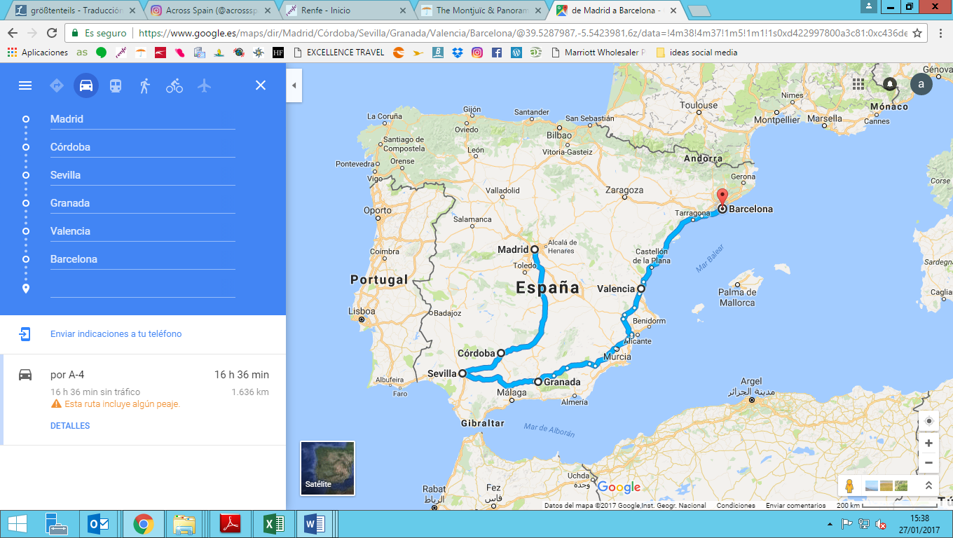

mapmarker2mapmarker2mapmarker2mapmarker2mapmarker2mapmarker2

**2n**

**Barcelona**

**1n**

**Córdoba**

**2n**

**Madrid**

**1n**

**Granada**

**1n**

**Sevilla**

**1n**

**Valencia**